CDA 3201L - Thursday (3:30 - 4:45PM) Section 005

Lab #02 - Combinational Logic Circuits (2)

9/15/2016 - Steven Romeiro, Jennyfer Munoz

**Purpose & Objectives:**

To show how the theoretical applications of combinational circuit logic can be directly demonstrated with the usage of proper Integrated Circuits (IC), LED’s, a 5v Power Supply and a Breadboard. Part A of the lab requires to implement a Boolean expression using only NAND gates, applying DeMorgan’s law and Boolean laws to express as a NAND operation, with only 4 NAND gates. Part B asks to design a logic circuit for a car’s signal light for the turning signals, breaks, and emergency lights for when they should and should not be turned on.

**Components Used:**

|  |  |  |
| --- | --- | --- |
| **Name** | **Type** | **Quantity** |
| 74LS32 | OR IC | 1 |
| 470 Ω Resistor | Resistor | 3 |
| LED | Red LED | 3 |
| Power Supply | 5v | 1 |
| Wire Kit | Assorted | 1 |

**Description:**

**Part A Simplilfication:**

Z = XY’ + X’Y

Z = X(X’ + Y’) + Y(X’ + Y’)

Z = X(XY)’ = Y(XY)’

Z = [X(XY)’]’’ + [Y(XY)’]’’ = [[X(XY)’]’ + [Y(XY)’]’]’

**Truth Tables:**

|  |  |  |  |  |  |  |
| --- | --- | --- | --- | --- | --- | --- |
| **X** | **Y** | **X’** | **Y’** | **XY’** | **X’Y** | **XY’+X’Y** |
| 0 | 0 | 1 | 0 | 0 | 0 | 0 |
| 0 | 1 | 1 | 0 | 0 | 1 | 1 |
| 1 | 0 | 0 | 1 | 1 | 0 | 1 |
| 1 | 1 | 0 | 0 | 0 | 0 | 0 |

**Diagram:**

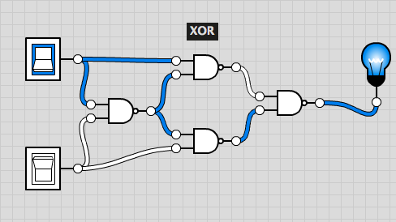

**Part B:** Design of a logic circuit for a car’s signal light, for the turning lights, brakes and emergency signal. See Diagram.

**Simplification -**

Lout = L’R’E + L’RE + LR’E + LR’E + LRE’ + LRE

Rout = L’R’E + L’RE’ + L’RE + LR’E + LRE’ + LRE

Simplify:

Lout = E(L’R’ + L’R + LR’ + LR) + E’(LR’ + LR)

Lout = E(L’ + L) + E’(L) - > Lout = E + E’L - > Lout = E + L

Rout = E(L’R’ + L’R + LR’ +LR) + E’(L’E + LR)

Rout = E(L’ + L) + E’(R) -> Rout = E + E’R - > Rout = E + R

**Truth Tables:**

**Output**

|  |  |  |  |  |
| --- | --- | --- | --- | --- |
| **L**s | **R**s | **E** | **L** | **R** |
| 0 | 0 | 0 | 0 | 0 |
| 0 | 0 | 1 | 1 | 1 |
| 0 | 1 | 0 | 0 | 1 |
| 0 | 1 | 1 | 1 | 1 |
| 1 | 0 | 0 | 1 | 0 |
| 1 | 0 | 1 | 1 | 1 |
| 1 | 1 | 0 | 1 | 1 |
| 1 | 1 | 1 | 1 | 1 |

|  |  |
| --- | --- |
| **Brake** | **Taillights** |
| 0 | 0 |
| 1 | 1 |

**Diagram:**

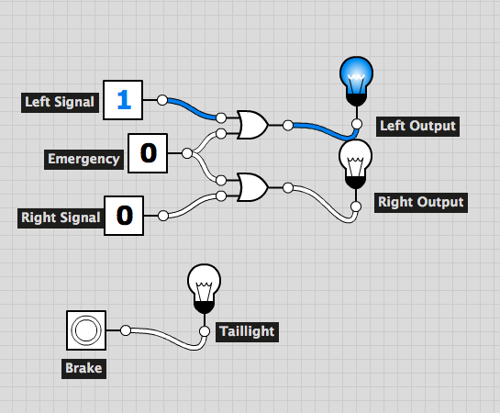

**Discussion & Conclusion:**

Based on our designs we were able to implement the Boolean expression using only 4 NAND gates. Through the application of DeMorgan's law and Boolean laws to go from one to the other as was shown in the simplification, our results was tested with the Integrated Circuits and the Breadboard. In Part B, we designed a logic circuit for a car’s signal lights in which if the emergency lights were on both of the turning signals would also turn on. This was achieved through the creation of a truth table and then being able to carefully simplify both of the turning lights. Then it was found the common point for both and a new function was able to be formed and from that came the design for the logic circuit, even though it took a few tries to simplify correctly. The factor of the emergency brake having a governing power proved that we needed to use OR gates. Additionally on the side we had a brake signal that had the taillights. Through all of this is that the logic circuit is able to do the same as a car signal light.